Galderma New Contract Monthly Staging Area

User Documentation
Version 1.0


Contents
1 Document control 4
1.1 About this document 4
1.2 Changes made to this document 4
1.3 Purpose of this document 4
1.4 Audience for this document 4
2 Assumptions and constraints 5
3 Process 6
4 QC 10
5 Process 18
6 Appendix 19
6.1 Appendix A1: Download FTP Information 19
6.2 Appendix A2: Download Server Information 19
6.3 Appendix A3:Processing Server Information 19
6.4 Appendix A4:File Express Information 19

Document control

About this document
Author | Anika Nower
Published
File location
Status
Confidentiality | This document is confidential and must not be distributed outside of IMS Health.
Copyright | © 2026 IMS Health Incorporated or its affiliates. All rights reserved.

Changes made to this document

Version | Sections changed or created | Date of change | Author or contributor name | Role | Change summary
 |  |  | Anika Nower

Purpose of this document
The purpose of this document is to describe Galderma New Contract Monthly Staging area.
- Regular new contract
- Name type contract
- MKT contract

Audience for this document
This document has been written for:
- Production team members

Assumptions and constraints

ID | Assumptions

ID | Constraints

Process
Step# | Step Description
Sample mail
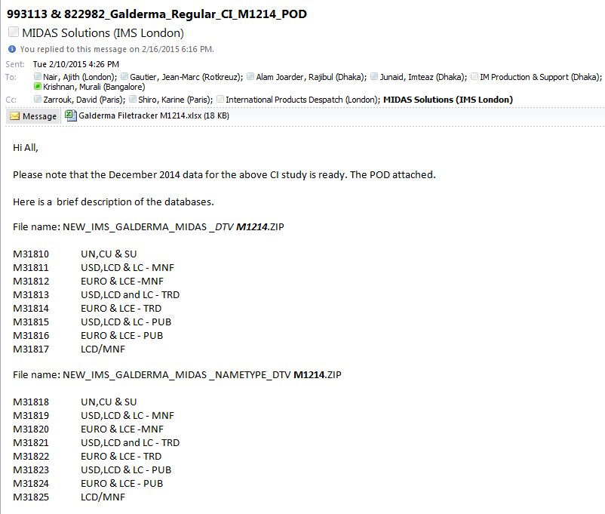
 | 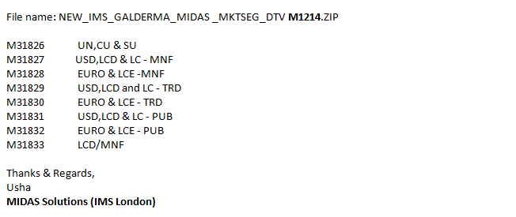
Log in to server to download the input file using
162.44.12.72
User name : PINASVC-IMAdmin
Password: !nf0_MgmT

Open IE , and goto http://www.imsportal.com/
Login with
id :: RAlamJoarder@bd.imshealth.com
Password:: centr1n0
 | Select Favorite Products →IMS File Express Administration → IMS File Express Menu →IMS File Express
Download and copy the file to \\162.44.22.161\d$ Address
CustomData \Galderma_midas_feed\Input\Monthly\Monthly New Contract

 | Log on to the server using Appendix A3 (162.44.22.161)
Go to D:\CustomData \Galderma_midas_feed\Input\Monthly\Monthly New Contract
Unzip the file using Extract Here.

 | First Open MONTHLY REGULAR folder.
Check all 8 files are there or not. Usually ignore the last file.(delete file)
Rename the file
- Check which file include UN, CU, SU only from mail. Rename with M01.zip
- Check which file include LC, USD, LCD at MNF level from mail. Rename with M02.zip
- Check which file include EURO & LEU at MNF level from mail. Rename with M03.zip
- Check which file include LC, USD, LCD at TRD level from mail. Rename with M04.zip
- Check which file include EURO and LEU at TRD level from mail. Rename with M05.zip
- Check which file include LC, USD, LCD at PUB level from mail. Rename with M06.zip
- Check which file include EURO & LEU at PUB level from mail. Rename with M07.zip

Unzip all the file using Extract to folder name
[for example: M01.zip as M01, M02.zip as M02, M03.zip as M03, M04.zip as M04, M05.zip as M05, M06.zip as M06, M07.zip as M07]
 | Repeat above steps from 9 to 11 for NAME TYPE and MKT folder
PIVOT:
Open table M01 and M01_sum using database galderma_midas_feed_new_contract for checking the columns for Regular feed.
Go to location
D:\PADDS Convert Tool\Convert50
Open convert.exe
1.Click analyze from menu bar.
2.Browse source file mask: D:\CustomData\Galderma_midas_feed\Input\Monthly\Monthly New Contract Monthly\M01
3.Select .PRM file and open
4.Select Monthly
5.Click Scan Directory
6. Check Export headers, Norm. Periods
7.Click Edit Hierarchies
8. Delete all .DLL file
for MNF, INTPRD , MOL delete all Additional Description
for PRD - with out LDATE ,delete rest of Additional description

 | Click ok
 | Click convert→ yes
- on | One massage will show with the last line ready.
 | Close Hierarchies, close window.
 | For M02, M03, M04, M05, M06, M07 follow step 14 to 19.
 | Open table M01 and M01_sum using database galderma_midas_feed_new_contract_CR_nametype for checking the columns for NAME TYPE feed.
Go to location
D:\PADDS Convert Tool\Convert50
Open convert.exe
1.Click analyze from menu bar.
2.Browse source file mask: D:\CustomData\Galderma_midas_feed\Input\Monthly\Monthly New Contract Monthly\M01
3.Select .PRM file and open
4.Select Monthly
5.Click Scan Directory
6. Check Export headers, Norm. Periods
7.Click Edit Hierarchies
8. Delete all .DLL file
for MNF, INTPRD , MOL delete all Additional Description
for PRD - with out LDATE ,delete rest of Additional description
 | Click ok
 | Click convert→ yes
 | One massage will show with the last line ready.
 | Close Hierarchies, close window.
 | For M02, M03, M04, M05, M06, M07 follow step 23 to 27.
 | Open table M01 and M01_sum using database galderma_midas_feed_New_Contract_MKTSEG for checking the columns for MKT feed.
Go to location
D:\PADDS Convert Tool\Convert50
Open convert.exe
1.Click analyze from menu bar.
2.Browse source file mask: D:\CustomData\Galderma_midas_feed\Input\Monthly\Monthly New Contract Monthly\M01
3.Select .PRM file and open
4.Select Monthly
5.Click Scan Directory
6. Check Export headers, Norm. Periods
7.Click Edit Hierarchies
8. Delete all .DLL file
for MNF, INTPRD , MOL delete all Additional Description
for PRD - with out LDATE ,delete rest of Additional description
 | Click ok
 | Click convert→ yes
 | One massage will show with the last line ready.
 | Close Hierarchies, close window.
 | For M02, M03, M04, M05, M06, M07 follow step 31 to 35.
Now for three feed do the same process:
go to M01 folder and rename .out file to M01.TXT
go to M02 folder and rename .out file to M02.TXT
go to M03 folder and rename .out file to M03.TXT
go to M04 folder and rename .out file to M04.TXT
go to M05 folder and rename .out file to M05.TXT
go to M06 folder and rename .out file to M06.TXT
go to M07 folder and rename .out file to M07.TXT
Go to D:\CustomData\Galderma_midas_feed\SSIS\galderma_midas_feed_New_Contract
Open galderma_midas_feed.sln
Run Monthly_New_Contract.dtsx
Output file IMS_GALDERMA_MIDAS_FF_Mmmyy.txt will generate in location D:\CustomData\Galderma_midas_feed\Output\monthly\monthly new contract
Rename the file with latest time period
Zip the file
Backup the Output text file and zip file in a folder named with the latest period at-
D:\CustomData\Galderma_midas_feed\Output\Monthly\Monthly New Contract\Old
For delivery:
Log in to server using Appendix A4 to Appendix A2
 | Copy the output zip using \\162.44.22.161\d$
Select Favorite Products →IMS File Express Administration → Add new file→browse select the output zip file.
Template :Galderma
File description: New contract delivery for Mmm/YY MIDAS Monthly data
Save all.
Go to D:\CustomData\Galderma_midas_feed\Input\Monthly\Monthly New Contract\Old
Create a New folder named MmmYYYY
[For example, the folder name M042012]

Take backup of the files in D:\CustomData\Galderma_midas_feed\Input\Monthly\Monthly New Contract to the newly created MmmYYYY folder.

QC
1 | Copy:  Monthly_MAT_Template.xls  Finaltest.xls  Book1.xls  IMS_GALDERMA_MIDAS_FF_VALIDATION_MAT_Mmmyy.XLS  IMS_GALDERMA_MIDAS_FF_VALIDATION_MTH_Mmmyy.XLS  files from previous month folder to  D:\CustomData\Galderma_midas_feed\Input\Monthly\Monthly New Contract
2 | Steps of QC:  Step 1: open IMS_GALDERMA_MIDAS_FF_VALIDATION_MTH_Mmmyy.XLS
3 | Open .prm file from M01 folder. See screenshort below:
 | 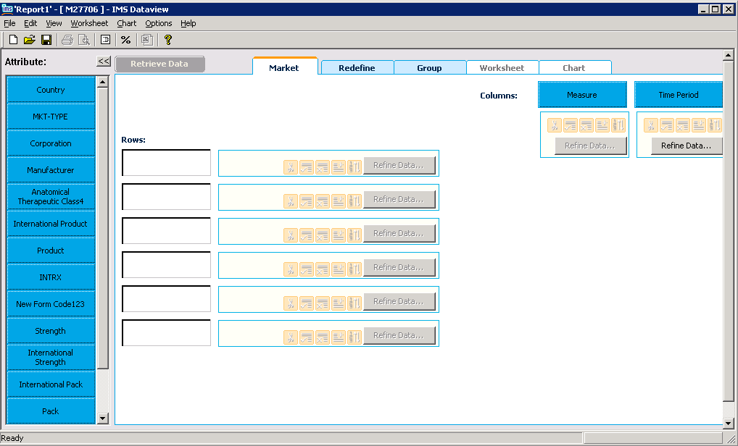
4. | Click “Country”,. Click “Add all” and then “OK”. See screenshot below:
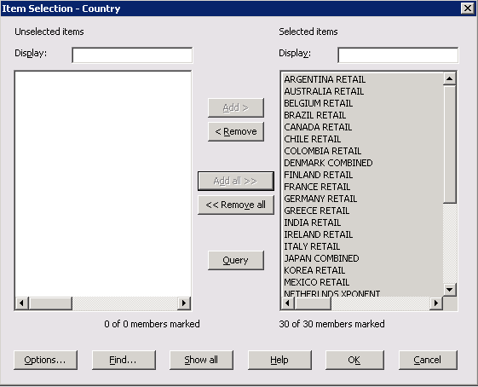
Click “Redefine Data” . Select “Ascending” and “Alphabetic” and click OK. See screenshot below:

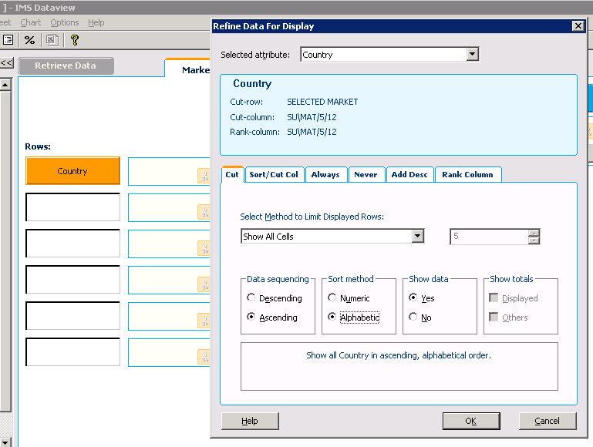
5. | Click “Measure”,. Click “Add all” and then “OK”. See screenshot below:
 | 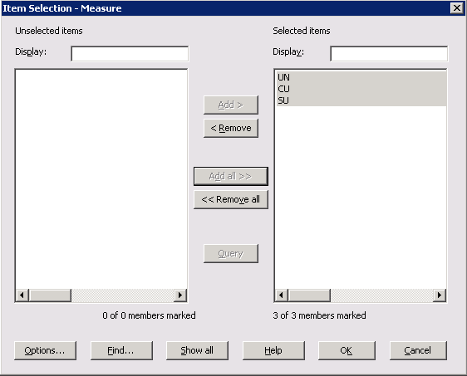
6. | Click “Period”, select latest month from the list. Click “Add” and then “OK”. See screenshot below:
 | 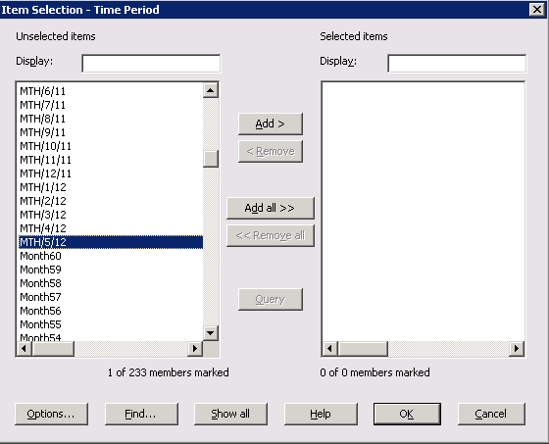
7. | Click “Retrieve data”,. Then copy the value from dataview
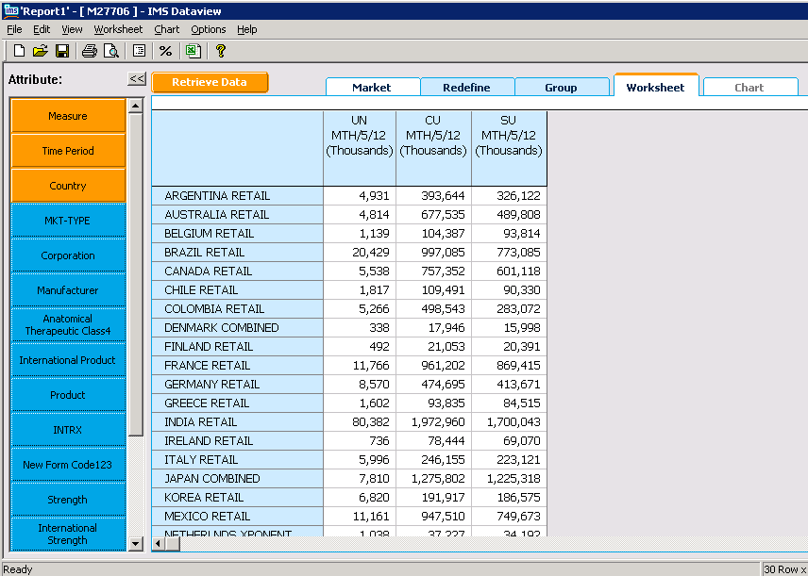
And paste in dataview sheet. See the screen short below:
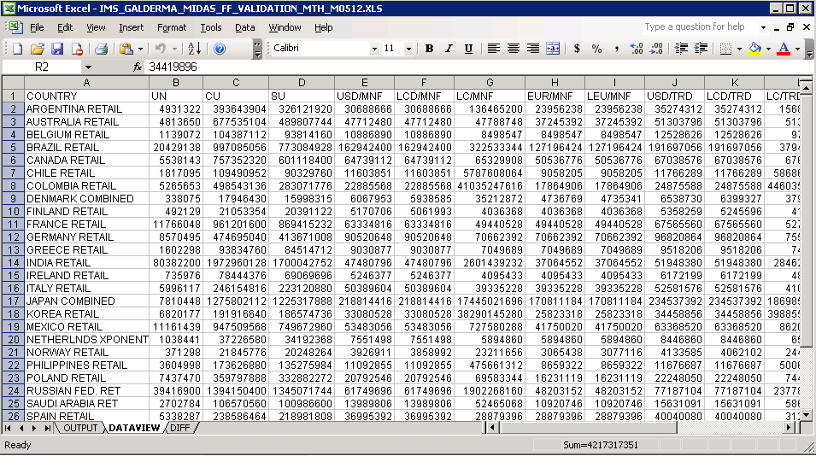
8 | Repeat this 3 to 7 for M02 to M07
9 | Now log on to SQL Server 2005
10 | Run MTH_QA_NewContract.sql from D:\CustomData\Galderma_midas_feed\Tools\SQL
11 | Paste result into output sheet
12 | Check DIFF page that Diff should be 0.0000%
13 | Step 2: open Monthly_MAT_Template.xls
14 | Now open .prm file from M01 folder  Click “Period”, select MAT1 from the list. Click “Add” and then “OK”. See screenshot below:  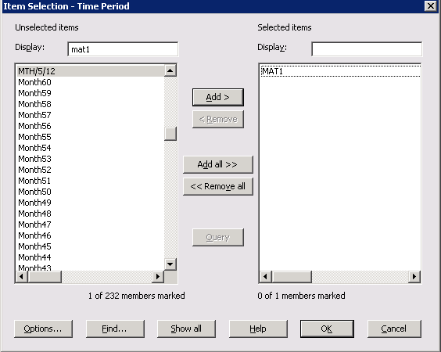  Click “Retrieve data”,. Then copy the value in MAT1 sheet  Repeat this for .PRM files in folder M02 to M07 to select the MAT1 value.  Repeat this for MAT2, MAT3, Mat4, Mat5 for these 7 .PRM files.
15 | Open Finaltest.xls  Copy all values of MAT1 from Monthly_MAT_Template and paste on Finaltest-MAT1 sheet  Repeat this for MAT2, MAT3, Mat4, Mat5
16 | Open Book1.xls  Copy MAT1 from Finaltest and paste Book1 MAT1. Check that the values should be rounded.
17 | Open IMS_GALDERMA_MIDAS_FF_VALIDATION_MAT_Mmmyy.XLS  Copy two part from Book1 and paste IMS_GALDERMA_MIDAS_FF_VALIDATION_MAT_Mmmyy.XLS  See the diff is 0.0000%

5 Process

The table below lists other materials that are relevant to this document.
Title | Author | Version | Date | Location

Appendix

Appendix A1: Download FTP Information
Key | Value
FTP Server: | ftp-emea.rxcorp.com
Username: | D08044
Password: | CHProd
Location: | /Level1 PTRi/Client/Respective Month Name

Appendix A2: Download Server Information
Key | Value
Server Address: | 162.44.12.72
Username: | PINASVC-IMAdmin
Password: | !nf0_MgmT

Appendix A3:Processing Server Information
Key | Value
Server Address: | 162.44.22.161
Username: | DACASVC-GDCRDPAdmin
Password: | !nf0_MgmT

Appendix A4:File Express Information
Key | Value
URL: | www.imsportal.com
Username: | ijunaid@bd.imshealth.com or RAlamJoarder@bd.imshealth.com
Password: | B1hanga or centr1n0

